**Volunteer Toolkit Overview**



The Girl Scout Volunteer Toolkit (VTK) is a comprehensive digital tool accessible on your computer, smartphone, or tablet.Affectionately called the “Administrative Assistant” to the troop leader, this addition to Girl Scouting will make it easier to help girls put their plans into action!

Who can access the Volunteer Toolkit (VTK)?

All troop leaders and parents can access VTK. Leaders can use VTK for troop management and meeting planning. Parents can view their child’s information and meeting plans only. If you need assistance accessing VTK, please contact Customer Care at [customercare@gsnnj.org](mailto:customercare@gsnnj.org). Leaders are encouraged to login and get familiar with the functionality and available materials. It will make it much easier to manage your troop and engage parents.

Accessing the VTK

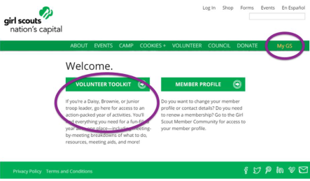As an approved troop volunteer, you canvisit our websiteand click on the yellow

**MY GS**tab, where you will enter your login to gain access. The VTK can be used from any computer or electronic device with internet capability. You can print meeting plans or download them to your personal computer using remote internet access.



Using the VTK to manage your troop

Daisy through Junior-level leaders will have access to three full-year plans, including one year of Girl Scout badges and a choice of two Girl Scout Journeys. These pre-made plans provide everything you need to get started. You can set your meeting calendar to include locations, dates, and times. You can customize activities, delete ones that your girls don’t want to do, and replace them with new ones. The VTK also allows leaders to keep attendance and trackthe badges each girl earns.

Although the Cadette through Ambassador-level badge and Journey program resources are not currently loaded in the VTK, girls and their advisors

Using theVTKtomanage your troop (Continued)

can use the “Create Your Own Year Plan”function to plan meetings. Older girl badge and Journey program resources will be available soon. Stay tuned for details.

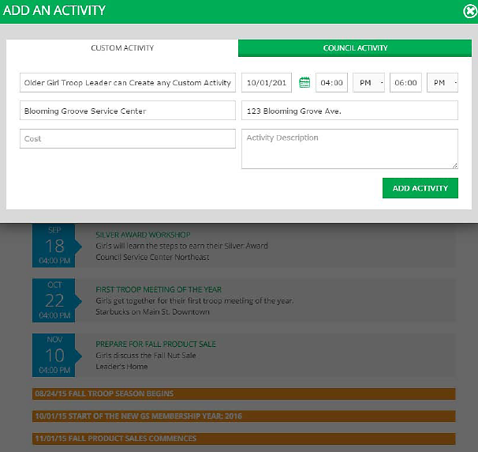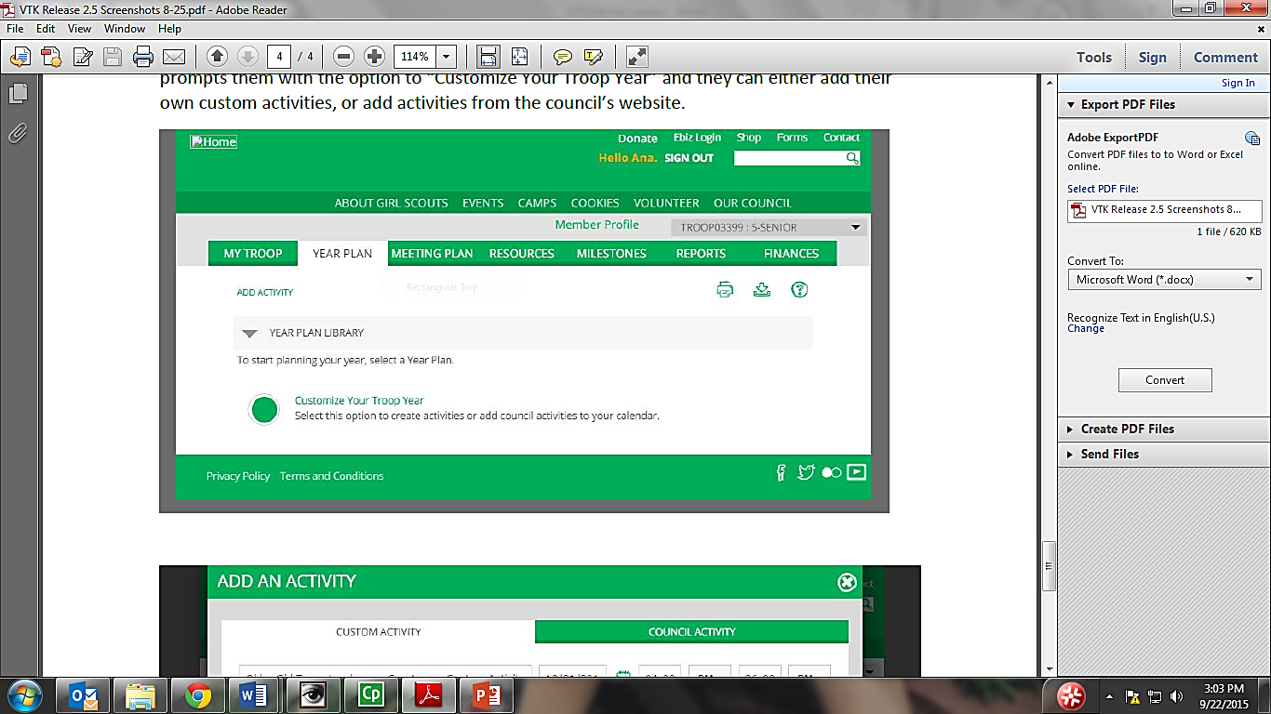

Want to learn more?

Look for VTK webinars and recorded trainings on our website [www.gsnnj.org](http://www.gsnnj.org)

Using the VTK to communicate with troop families

Since it is connected to the GSNNJ member registration system, the VTK allows all leaders to manage troop contacts and communicate with families. You can easily generate customized emails that tell families what to expect at each meeting.

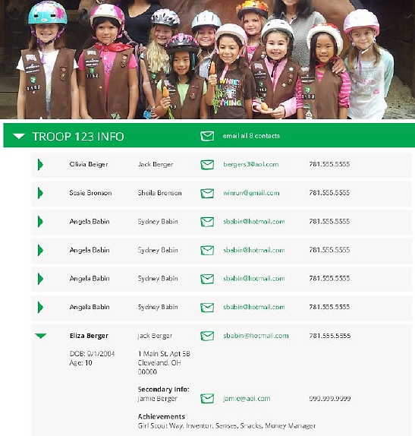

Using the Volunteer Toolkit



You must be a currently registered adult and an approved Troop Leader for your troop to access and make changes to the Volunteer Toolkit (VTK) functions. To access the Volunteer Toolkit, go to [www.gsnnj.org](http://www.gsnnj.org) and click on the**MY GS**tab. Enter your login information. If you need help logging in, please contact our Customer Care team.

**The following five tabs make up the Volunteer Toolkit:**

Manage troop contacts, track awards and badges, track attendance, and communicate with parents/guardians.

My Troop

* Click on a girl’s name to see detailed information like her address, birthday, and phone number.
* You can see a list of awards, badges, and attendance in each girl’s record.
* Click on email contacts to email all the families in your troop.

For Daisy, Brownie, and Junior leaders: when logging into the VTK for the first time, you will have four options under the Year Plan library: two Journey Year Plans (It’s Your Story and It’s Your Planet series), one plan for petals or badges, and one “Create Your Own” Year Plan. Cadette through Ambassador leaders will only see the “Create Your Own” Year Plan, as badge and Journey program resources are not yet available for these grade levels. Using these tools, girls can be more involved in planning their troop year. Multilevel troops will have a choice of Daisy, Brownie and/or Junior levels to choose activities for.

Year Plan

* The petal/badge and Journey Year Plans* are organized by 15 meetings in default order.
* Use the Specify Dates and Locations tab to set your meeting dates/times and troop meeting location. UnderCalendar,you can set meeting dates, frequency, and times (make sure to add in any holidays that will change your regular meeting times). Click “Update Calendar” to save your changes.UnderLocation, you can add your meeting location and address. Click “Add” to save your changes.
* To combine troop meetings, you can organize multiple meetings on the same date. To do this you need to click on the troop meeting date in your year plan. In the pop up box, click on the calendar and choose to combine meeting dates. Choose one date for both meetings and click save.
* Look for Milestones in orange to remind you of upcoming dates for council events, product sales, and other important dates you need to know.
* You can access last year’s year plans by clicking on the See Past Years tab.
* There are 18 meetings that offer ideas to girls outside using petal/badge activities-
  + Daisy- one meeting for each petal- Lupe and Clover
  + Brownie- two meetings for the following badges: First Aid, Making Games, Snacks, and Senses.
  + Junior two meetings for the following badges- First Aid, Detective, Simple Meals, and Staying Fit.
* In each meeting where there are outdoor links, you will see an evergreen tree symbol you can click on to see a choice between doing the activity inside or outside.  Depending on what you choose, the activity will be customized to the setting (and if you choose to do the activity outside, the tree turns green).

Customize activities, delete ones your girls don’t want to do, and replace them with new ones.

Meeting Plan

* Choose a meeting by clicking on the colored meeting date box. You must specify your meeting dates and location under the Year Plan tab to see your Meeting Plans.
* In each meeting you will see:
  + **Overview**- Click on the overview to see a quick summary of the meeting you are viewing.
  + **Activity Plan**- Gives you details of each meeting’s activities.
  + **Materials List**- Tells you everything you need for that meeting. *Hint: Journey Boxes are available to rent from our online Lending Library to help you with meeting materials.*
  + **Edit/Send Meeting Email** – Gives you a scripted email for families that you can edit as needed to remind them of what the girls will be doing at that meeting.
  + **Record Attendance and Achievements**– This is where you can keep track of what badges girls have earned and who was at each meeting. It is populated into each girl’s information in the My Troop tab.
  + **Meeting Aids**- Includes worksheets, songs, and other types of reference materials you will need for meeting activities. If there are outdoor components to the meeting, you may also see videos to help you get girls outdoors.
  + **Meeting Agenda**- Lists all the activities for the meeting with the recommended times for each activity. You can change the order of activities by “dragging and dropping,” or delete activities by clicking on the activity title. You can also edit the times allowed for each activity. Activities with an outdoor component will have an evergreen tree you can click on to get girls outside with the activity.
  + **Add Agenda Item**– This is where you can customize your meeting by adding additional activities (like celebrating Juliette Low’s Birthday) to customize your troop meeting.
  + **Your Opinion Matters!**- For meetings with an outdoor component, take the time to do a quick survey to let GSUSA know what you thought about the activities. This will help them to continue to improve VTK with your input.
  + **Add a Note**- you can leave notes to the other leaders in your troop to see. Parents cannot view notes.
  + Select **Year Plan** to return to your troop’s year plan.

Search the Volunteer Toolkit for meeting aids.

Resources

* Search by typing in the name of the resource you are looking for (like a kaper chart) and you can add it to any meeting in your year plan. You will not be able to access resources from our website using this tab.

The VTK finance tab is not currently used. All the finance forms you will need are located on our website on our Troop Packet page –

Finances

**What if I am leading multiple troops or a multilevel troop?**

* If you manage more than one troop, the Volunteer Toolkit has a drop down tab located above the Finance tab that allows you to switch back and forth between your troops.
* If you are a multilevel troop, when you go to Year Plan Library you will have the option of “**Create your Multi-Level Troop Year Plan**”.
* Click **Create Your Year Plan** and then choose what age levels you want (Daisy, Brownie and/or Junior).
* Once age levels are selected, you can choose between Badge, Journey, Award Earning, Intro and Closing.
* Choose your meeting plan type(s) and click **View Meeting Plans**.
* Choose the meeting plans you want. Make sure if a badge has two meeting plans (part one and two) that you choose both meeting plans.
* Click **Add To Year Plan** to add your meetings.
* To combine meetings on one date (this way you can have your Daisy, Brownie and/or Junior meetings on the same date), you need to click on the colored meeting date box for the date you want to combine meetings. Find your meeting date and click on the calendar icon. This will open a box with the choice to Change Date/Time, Cancel Meeting or Combine Meetings. Choose Combine Meetings and click on the meetings you want to combine. Click Continue and use the calendar to choose the date for those meetings to occur. Click Save and when you view your Year Plan, you will see multiple meetings on that date.

Using the Member Profile



As a currently registered adult and an approved Troop Leader, the Member Profile section under the **MY GS**tab allows you to manage your membership, view troop information, and edit your personal information.

**The following tabs make up the Member Profile section:**

MEMBERSHIP

View your household membership.

Renew your role as a leader, view your girl and adult troop members, re-register your troop members and view/edit your troop meeting information.

TROOPS

Edit your personal information, including email preferences.

FAMILY PROFILE

The Activities tab is not currently available in the Member Profile. To register for camp, programs, events, and adult learning opportunities, visit

ACTIVITIES

www.gsnnj.org and click on the Activities tab.

The My Activities tab is not currently available in the Member Profile. To view and register for activities, visit www.gsnnj.org and click on the Activities

MY ACTIVITIES

tab.

Volunteer Toolkit Frequently Asked Questions



You probably have a lot of questions about the Volunteer Toolkit. We’ve put together a list of frequently asked questions to help you get started. Don’t see what you’re looking for? Contact our Customer Care team at [customercare@gsnnj.org](mailto:customercare@gsnnj.org) or 973-248-8200with any additional questions.

1. Why can’t I register for programs, camp, etc. through the VTK?

* Currently, you can only register or renew membership through the VTK. To do so, visit gsnnj.org and click on the MY GStab to access the Volunteer Toolkit.
* To register for camp, programs, and learning opportunities, visit gsnnj.org and click on the Activitiestab.
* Your login information is the same for both systems.
* In future updates, these two systems will be combined for easy access.

2. Why does the VTK only includeYear Plans for K-5 troops?

* In order to use our resources wisely, we had to narrow our focus when initially implementing the VTK.Since older girls have more experience making decisions and planning their own meetings, we chose to implement the K-5 meeting plansfirst.
* Older girl troops can still use the VTK to communicate with families and plan meetings with the Create Your Own Year Plan function.
* Additional resources for older girl troops will be rolled out in the future.

3. What is not in the VTK?

* As noted above, Council Activities are not presently integrated into the VTK, but will be in the future.
* There is no Year Plan in the VTK for the *It’s Your World* Journey series. Refer to theadult Journey guide.
* Financial tracking. Continue to access troop financial forms from our website.
* Information on Highest Awards, bridging, safety awards, and additional badges and awards are not included in the VTK. Refer to the*Girls’ Guide to Girl Scouting.*

4. What can parents/caregivers view in the VTK?

* Parents/caregivers can log in to their online account using the MY GStab on our website and view parts of the VTK, although they cannot make any changes.
* Using the Troop tab, parents can view their girl’s membership, but cannot see other girls’ information.
* They can view the Year Plan and Meeting Plan, and search for Resources.
* Parents/caregivers can use their online account to make changes to their Girl Scout’s information (contacts, membership, family profile), but cannot change the troop information.

5. If I don’t have internet at my meeting place, how will I access the VTK?

* You can download and save your VTK plans into any digital device, laptop, tablet, or smart phone.
* You can also print VTK plans to take with you to your meeting.

6. What about volunteers who don’t have internet access at home?

* The VTK can be accessed from any electronic device – tablet, smart phone, or laptop – with internet capability. Libraries are a great resource for those who don’t have access to internet at home. You can print meeting plans or download them onto an electronic device to use without internet access at your meeting.